|  |  |  |  |  |
| --- | --- | --- | --- | --- |
| |  | | --- | | the second international conferenceInteractive Media in the Arab World: Promise and Performance | | Name:  Nationality:  Occupation:  Specialty:  Employer:  Degree:  Type of Participation:  Paper ( ) Working Paper ( )  Paper/Working Paper Title:  Address:  Telephone:  Mobile Phone:  Fax:  E-mail: | | |  | | --- | | NOTEPlease attach to this form your abstract (300 words), your CV, your digital photo, and a copy of your passport for non-Saudi nationals (page with picture) for visa processing. | |

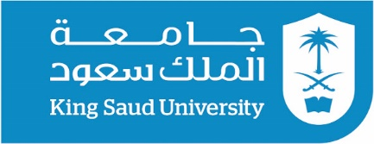

# King Saud University – Riyadh – Kingdom of Saudi Arabia